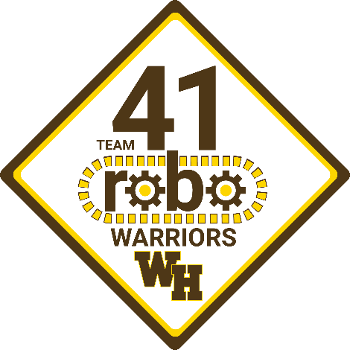
FIRST​TM​ Robotics Competition (FRC) TEAM 41

Who are the RoboWarriors?
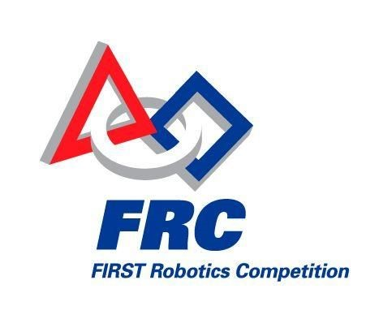
The RoboWarriors – better known as Team 41 – are the Watchung Hills Regional High School (WHRHS) robotics team that competes in the annual FIRST Robotics Competition (FRC). Every year, the team designs, builds and tests a custom robot to compete in a brand new robotics challenge. The team size changes every year, but we average around sixty students, working on five different sub-teams (business, mechanical, electrical, programming and design).

What is FRC?
FIRST, which stands for “For Inspiration and Recognition of Science and Technology,” is a not-for-profit charity organization founded in 1989 to inspire young people’s interest and participation in science and technology. Each year, FIRST designs and runs a series of robotics programs for various age levels, including FIRST Robotics Competition (FRC) for high school students. FRC is the big leagues of robotics competition. FRC teams design and build their robots completely from scratch, and the designs are limited only by the creativity of the individual teams. FIRST releases the annual challenge in January, and teams have only six weeks to design, build and perfect their entry. It's a grueling six weeks, and along the way, the team members learn valuable lessons about engineering, teamwork, time management, and perseverance.
How do we build a robot?
Every robot is custom designed specifically to meet the unique challenges of the current competition. Since the challenge is different every year, so is the robot. The team designs the robot, chooses the necessary mechanical, electrical, optical and pneumatic components that are commercially available, and then builds whatever else is needed in the high school machine shop. Meanwhile, another part of the team works on the software necessary to drive and control the robot, including specialized targeting software and autonomous control software that can earn valuable bonus points. The hardware and software come together, and then the team tests the robot, makes any tweaks that are necessary and starts practicing the all-important driving skills. If it sounds hard, that's because it is.
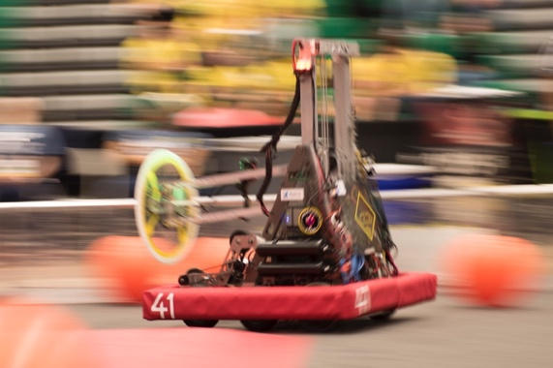
How to support the RoboWarriors
WHRHS provides annual support to the RoboWarriors in terms of competition fees and local travel. However, the funding does not cover the annual cost of robot parts, workshop supplies or purchasing upgraded tools and machinery for the team workshop. In 2008, team parents founded a 501(c)(3) non-profit organization, the Watchung Hills Education and Technology (WHEAT) Foundation, to raise funds to support the robotics program as well as other STEM-related events at WHRHS. In conjunction with the WHEAT Foundation, Team 41 has established a corporate sponsorship program to seek additional financial support from the community. The following sponsorship opportunities are available and provide different levels of marketing opportunities:
■ Bronze: $100 - $499
■ Silver​: $500 - $999
■ Gold​: $1000 - $4999
■ Platinum: ​$5,000 and above
Companies interested in sponsoring the RoboWarriors for the upcoming season can complete the attached sponsorship form or contact the WHEAT Foundation at ​wheatfoundation@gmail.com​ for additional information or to make arrangements to purchase a sponsorship.
More information can be found at the WHEAT website: https://www.wheatrobotics.org .
Why sponsor the RoboWarriors?
The RoboWarriors are the engineers of tomorrow. The majority of the team members go on to study STEM-related fields in college, and the valuable skills we learn from our participation in FRC help prepare us to excel in college and beyond. By helping the RoboWarriors today, you are really investing in the world of tomorrow. Thank you for your consideration, and we greatly appreciate any support you can provide.

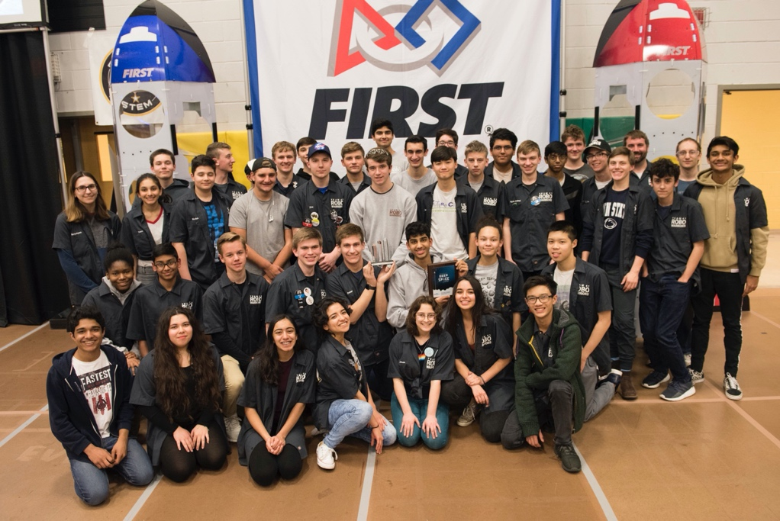

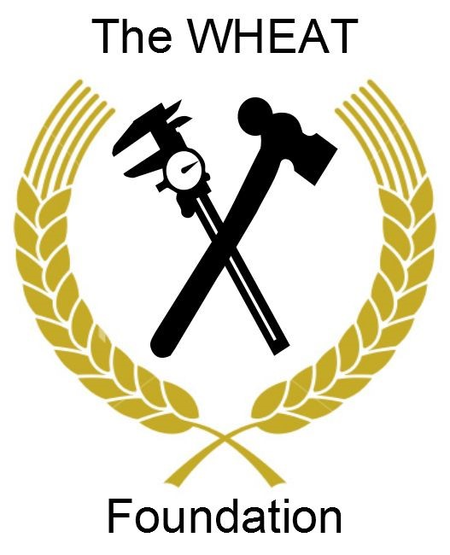

SPONSORSHIP CATEGORIES:
PLATINUM Sponsor
- $5,000 + Donation
- Company logo on the Robot
- Company logo in the Team Pit area
- Company logo on team & WHEAT websites
- Framed signed team photo
- Periodic updates from the team during build and competition season

GOLD Sponsor
- $1,000 - $4,999 Donation
- Company logo in the team pit area
- Company logo on the team & WHEAT websites
- Framed signed team photo
- Periodic updated from the team during build and competition season

SILVER Sponsor
- $500 - $999 Donation
- Company logo on the team website
- Signed team photo
- Periodic updates from the team during build and competition season

BRONZE Sponsor
- $100 - $499 Donation
- Periodic updates from the team during build and competition season

All sponsorships are tax-deductible contributions to a 501(c)(3) non-profit organization

Please select desired sponsorship level: ____Platinum ____Gold ____Silver ____Bronze

Company Name: _____________________________

Contact Person __________________________________

Contact Phone Number: _____________________________

Contact Email ___________________________________

Company Address: _____________________________________________________________________________

_____________________________________________________________________________
Please send a check and completed form to: WHEAT Foundation, PO Box 4177, Warren, NJ 07059

